document title/ titre du document
ROCADE user manual

prepared by/préparé par | Philippe Schweiger
reference/réference | OPS-EMD/ps/2006-002
issue/édition | 1
revision/révision | 0
date of issue/date d’édition | 25-08-2006
status/état | Draft
Document type/type de document | Technical Note
Distribution/distribution
APPROVAL
Title  titre | ROCADE USER MANUAL | issue  issue | 1 | revision  revision | 0
author  auteur | Schweiger Philippe | date  date | 25-08-2006
approved by  approuvé by |  | date  date
CHANGE LOG
reason for change /raison du changement | issue/issue | revision/revision | date/date
CHANGE RECORD
Issue: 1 Revision: Error: Reference source not found
reason for change/raison du changement | page(s)/page(s) | paragraph(s)/paragraph(s)

Table Of Contents
1 Introduction 1
2 Definitions and Abbreviations 1
2.1 Definitions 1
2.2 Abbreviations 2
3 User Permissions 2
3.1 Authorized actions for .read.group 2
3.2 Authorized actions for .readwrite.group 2
3.3 Authorized actions for .projcontr.group: 2
4 ACCESSING ROCADE 3
5 Uplaoding a NEW document 5
6 Updating a document 6
7 Quick Report and file status 7
8 Search Option 7
9 Managing Directories 7
10 Browsing 10
11 Downloading a DOCUMENT 11
12 Actions on Documents 11
13 File history 12
14 Enabling FILE encryption 12
15 Setting user permissions 13
16 Folder level restrictions 14
17 Access level restrictions 15
18 Enabling HTTPS 15
19 Managing the distribution list 15
20 Appendix 1: Options for each status 16
21 Appendix 2: Rocade icons 17

Introduction
ROCADE is a simple document management system, with document exchange capabilities between authorized users via the Internet. ROCADE users need an Internet access, a web browser (Internet Explorer), and software to read/modify documents (Microsoft Office).
The objective of this User Manual is to provide knowledge on how to use ROCADE basic functions including the following operations: Accessing ROCADE, browsing folders, downloading documents, uploading documents and managing directories. Most of the different operations will be presented with the help of screenshots for easy understanding.
The latest version of ROCADE supports as an optional feature the encryption of documents as well as folder level access restriction. Information about these features and how to enable them will also be given in this User Manual.

Definitions and Abbreviations

Definitions
The following terms are used in this document:

Document A document in ROCADE is any kind of file: a word processor document, a spread sheet, an image, a PDF file, a compressed archive containing one or more files, an executable file.
Repository The repository is where the documents are stored. The ROCADE repository is organized hierarchically, much like the File system directory structure, and supports practically as many levels as supported by the underlying Operating System.
Project A project is the first level of the repository. ROCADE supports completely independent Projects.
Checked-in The document has been uploaded to the repository and is available for change by other users.
Checked-out A user is currently updating the document and it cannot be modified by any other user.
Excluded File is obsolete; it is not deleted because it is part of the Project's History. For example if two documents are merged one will be Excluded.
Frozen When the document has been completed and approved. A frozen document cannot be checked-in or checked-out.
Published This is the process by which a Frozen document is copied to another project. The purpose is that access to the document can be granted in its final state.

Abbreviations
The following abbreviations are used in this document:

ROCADE Repository with check- Out, Check-in, Archive and Document Exchange features

User Permissions
There are three levels of user permissions in ROCADE. Permissions for users are set at project level: .read.group, .readwrite.group and .projcontr.group. Here is the list of actions possible for each group:

Authorized actions for .read.group
Download file
Send Mail
Show Distribution List
Indexing the content of folders
View summary

Authorized actions for .readwrite.group
Cancel Check-out...
Cancel Exclude
Check-out
Confirm Cancel Check-out
Confirm Delete
Confirm Move
Confirm Rename
Confirm Unfreeze
Delete...
Exclude
Freeze
Move...
Rename...
Transfer To
Unfreeze...
Update summary
Upload file

Authorized actions for .projcontr.group:
Confirm Delete File
Confirm Transfer
Create directory
Delete File
Delete User
Delete directory
Edit File
Force Cancel Checkout
Manage Directory
Publish
Register User
Save File
Show Logs
Show all groups
Show user
Transfer...
Update Header
Update User
Update groups

ACCESSING ROCADE
Launch your browser; go to the URL corresponding to the index of ROCADE (http://rocade.esrin.esa.int/). You will see a list of projects already in ROCADE. Select your project. The steps included in the User Manual can be reproduced for any other project.
The following picture shows you the first page you will see when you connect to ROCADE and in a red frame the list of projects available. Click on the project you want to access.
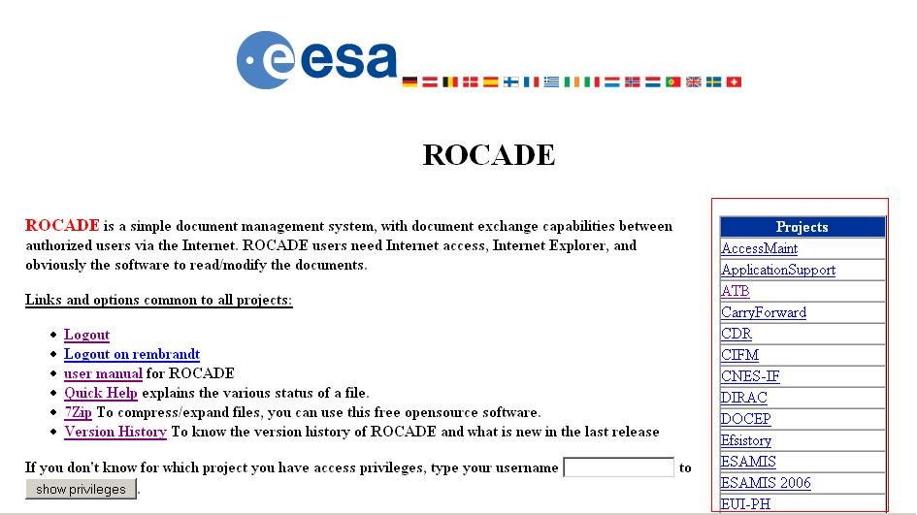

ROCADE is always asking to log in before accessing a project. With your provided login and password (this information is provided to you by Helpdesk) you should be able to access the project after clicking on it. A pop-up window will ask you your Username and Password and will redirect you to the folder of the project in case you have rights to access.

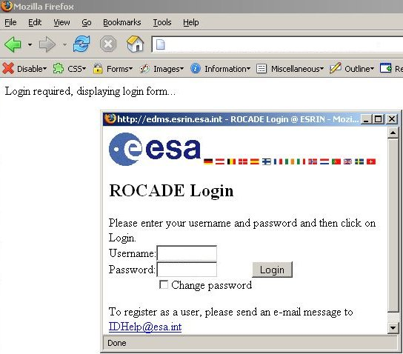

The next image shows you the first page you see when accessing the ATB project:

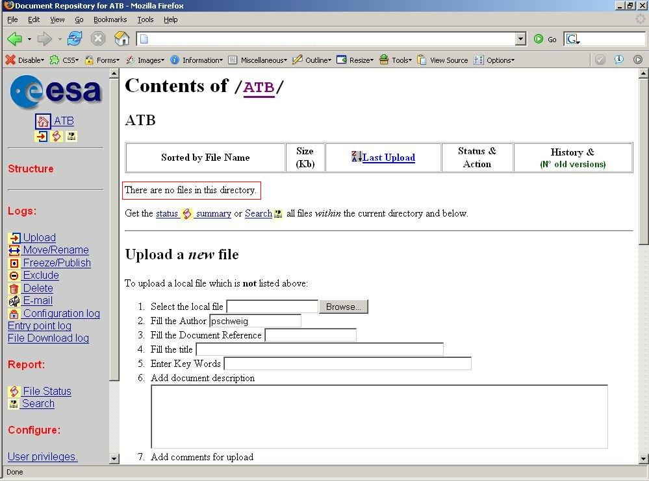

The red rectangle shows you the part in which you will see files and folders when they will be created.

Uplaoding a NEW document
To upload a document, make sure you are in the right directory (Project XXX, folder First-transfer in the screenshot) scroll down the right frame and access the “Upload a new file” as shown on the first picture. Use the browse button to select the local file you want to upload to ROCADE. Fill in the different information fields required. Press the upload file button to upload the file to ROCADE. If your project is configured with encryption, you will be asked to enter the encryption key. Make sure you put the right encryption key provided to you by the responsible of the project. A file will be uploaded to ROCADE only if the right encryption key is given.

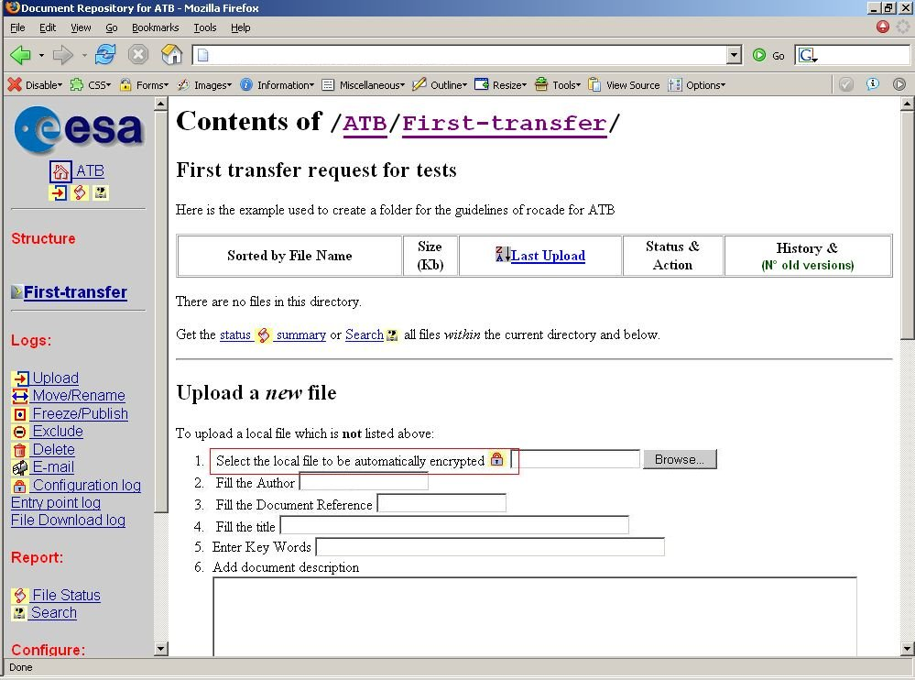

The second picture here shows you the results of a successful upload:
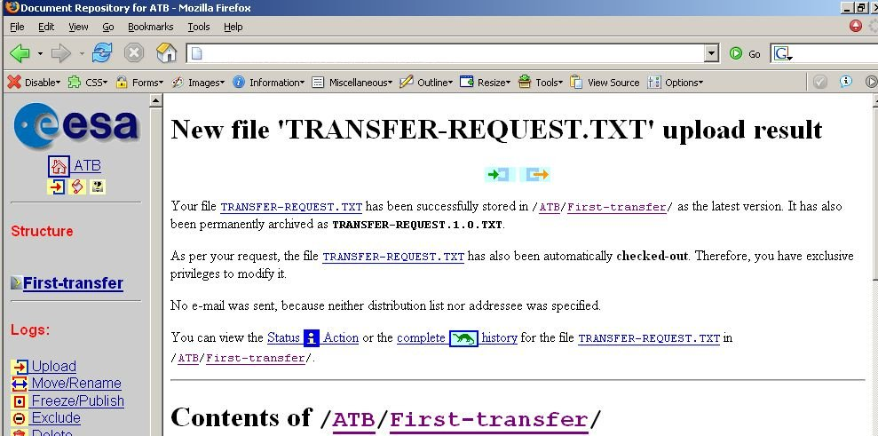

Updating a document
To update a document, you need to upload a new version of an existing file, the file must be Checked-out, i.e. you must have obtained exclusive privileges to make modifications. Navigate to the ROCADE directory containing the previous version of the file, click on the file’s Status/Action icon, and follow the instructions.

You must choose in which status you want your file to be after the upload:

Check-out | You keep yourself exclusive right to make further modifications to this file.
Check-in | Only after having marked this file 'Check-out' and downloaded it, you or other users will be allowed to make further modifications.
Frozen | This is the final version; no further modification is foreseen.
Note: As ROCADE reminds you on the screen:
• You cannot upload a file which has the same name as a file already in this directory.
• Filenames can be up to 30 characters, including the extension.
• To upload a new version of an existing file, the file must have been checked out (from the corresponding Status/Action).
• The maximum size of files that can be uploaded is fixed (currently 2500 Kilobytes). Should you need to upload larger files, please use a compression tool (such as winzip). If compression is not sufficient, contact the Server administrator.

Quick Report and file status
ROCADE has one report which can be invoked from the icon. This report lists files from the current level down in the hierarchical structure. These files are sorted by status (Check-in, check-out, etc.) and, within a status, in their hierarchy.
For each file, the following is given:
- Location in the structure and hyperlink to this directory
- File Name and hyperlink to this file
- File Title
- Number of “old” versions
- File Reference

To have all files of a Project, click on above the directory overview (left part of the window). To have all files within a given level, go to this level and click on the icon appearing below the list of files.

To get more information about file statuses please refer to this chart:

Documents in ROCADE are in one of four states: Check-in, Check-out,Frozen or Excluded, with the following meaning:
Icon | Name | Purpose
 | Check-in | File is Checked-in, i.e. it has been uploaded, and other users are authorised to check it out for further modification
 | Check-out | File is checked out, i.e. someone is modifying it.
 | Frozen | File is frozen, i.e. final version has been approved
 | Excluded | File is obsolete; it is not deleted because it is part of the Project's History.
 | Publish | File is Published, i.e. it has been copied to another project as a final version.

Search Option
ROCADE integrates a Search option, documents in a given project can be located by author, title or document keywords. The search finds documents matching any of the criteria and lists them according to the number of criteria matched.

Managing Directories
The documents in ROCADE can be organised hierarchically. Users with “Project Controler” privileges can create nested sub-directories.
Each directory can have a description. The first line of the Description is used as title, for example in the parent directory. The whole description will be printed before the list of files. Note that the description supports all kind of HTML tags, which provides you powerful display and feature control, if you know the HTML syntax.

To manage directories scroll down the right frame (right part of the window) to see the “manage directory” section.
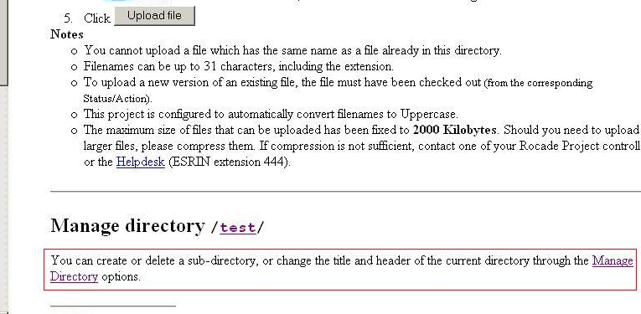

To create a directory inside your project click the manage directory link and fill the “create a sub-directory” form. Then click on the create directory button.
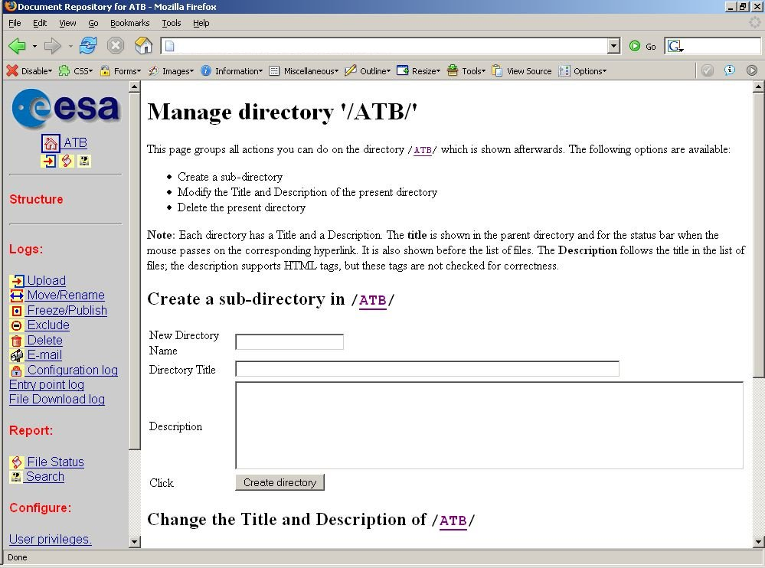

By scrolling down in the manage directory section, you will find options to modify folders:

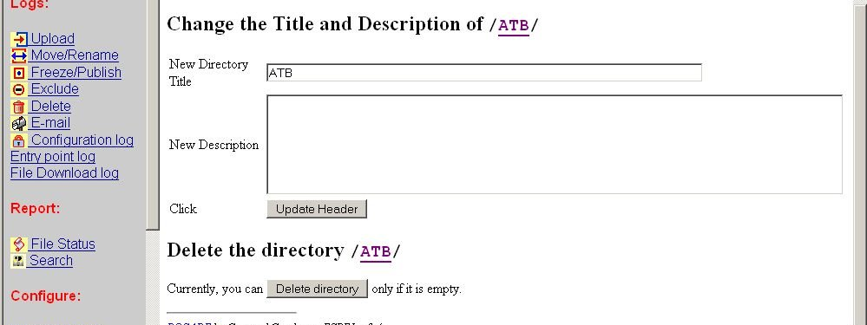

You can change a directory name and its description or even delete a directory.

In example, for each new set of documents, a new folder has to be created. This folder has to be created through the manage directory page. In this example we create a folder called first-transfer.

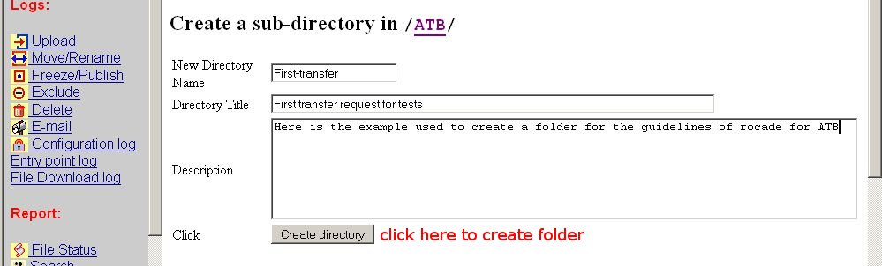

Once the folder is created:
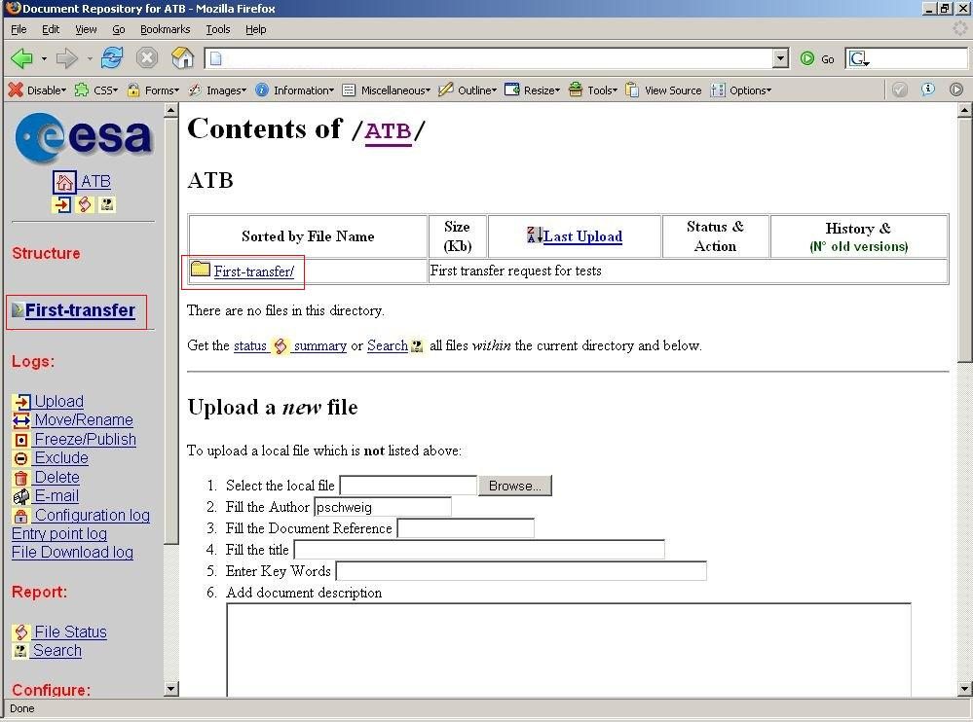

Browsing

Browsing folders inside a project is made very easy by the left navigation bar. Every folder created in the project is accessible from there:

Just left-click on the folder you want to access and the right frame will display the content of the folder.

Downloading a DOCUMENT
You can download any document in a project by clicking on the document in the list of files. If the project is configured for encryption, a pop-up window will ask you to provide the encryption key. The downloaded document will only be readable if the proper encryption key is given. If the project is not configured with encryption, the document is opened directly.

Actions on Documents
For each document, ROCADE allows to perform a certain number of actions depending on the user permissions. In order to perform an action on a file, search in the right frame of ROCADE for the button, “Status & Action” for the corresponding file as shown on the screenshot:
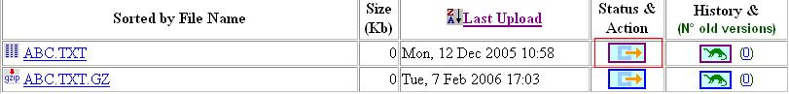

Once clicked, always in the right frame, scroll down to find the button “update summary” in order to change the information contained in the index card of the document.
Other actions are available scrolling down till the bottom of the right frame as show in the screenshot:
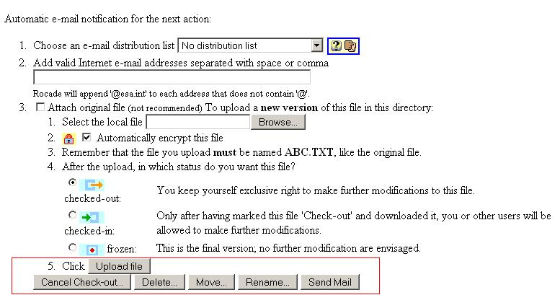

The following actions are available: cancel check-out, delete, move, rename and send mail.

File history
To access the history file please click on the icon.
The History file provides access to all versions of a given file which were uploaded. These previous versions have a special incremental suffix containing the number of uploads. For example, file T_MGT-CMT.3.0.DOC means that there are 2 previous versions of the file T_MGT-CMT.DOC in ROCADE, and this is the third version uploaded.
ROCADE indicates in several places the number of “old versions”, i.e. how many versions were uploaded before the current one.

Enabling FILE encryption
Administrators of projects have the ability to configure project options among which is the encryption feature. The encryption of documents consists in asking an encryption key (like a password) each time a file is accessed.
Scroll down the left frame of your internet browser and click on [Project XXX.] (replace XXX by the name of your project) as shown on screenshot:

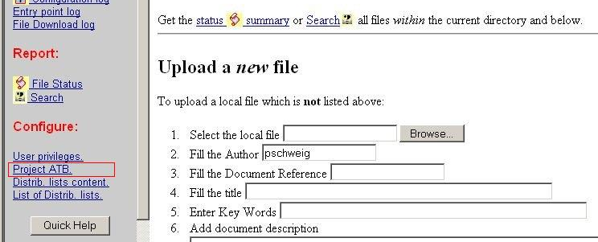

This page allows you to edit the configuration file of your project. Ensure that encryption is enabled by finding or adding the line:
Encryption = 2
Now scroll down through the explanations of the configuration in the same window:
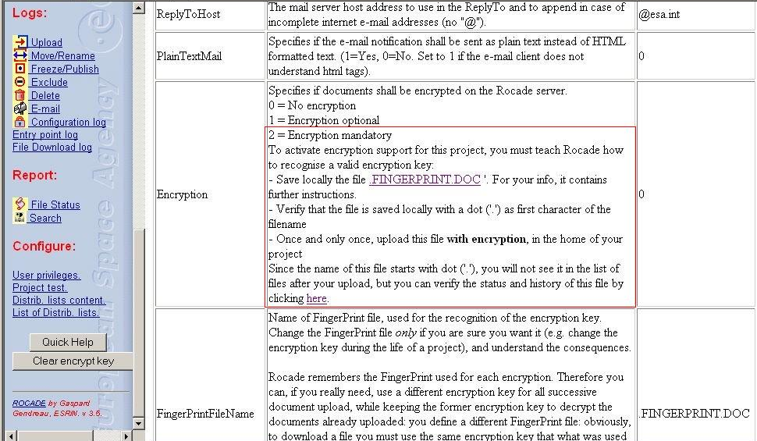

You will need to upload the file .FINGERPRINT.DOC on the root (not in a sub-folder) of your project folder. First download the file by clicking on the provided link. Then upload it on ROCADE. Uploading files is described in point 5 of the ROCADE User Manual. While uploading the file .FINGERPRINT.DOC, you will be asked for the encryption key. This encryption key is the key that will ensure security of the data. ONLY the same encryption key can decrypt the files that have been encrypted previously with an encryption key. If the key to an encrypted file is lost, the file is lost as no one will be able to read it. Therefore it is highly recommended to use the same encryption key for all the files. All persons that will have to access the encrypted files will need the encryption key to decrypt them. More information about encryption is available in the file .FINGERPRINT.DOC.

Setting user permissions
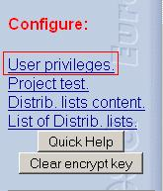
Only project controllers may set user permissions. To set user permissions, enter in your project and scroll down the left frame then click on User Privileges.

Following the example of the next screenshot, setting permissions is done by adding the username of a user in the box corresponding to the permissions you want to give to the user. If user needs read only permissions, his name should be added in the “Group '.read.group'” box.
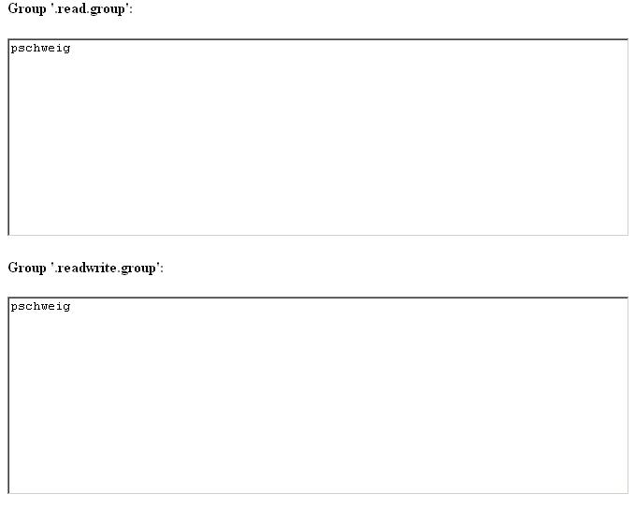
As explained already in this user manual, there are three levels of permissions available:
Group '.read.group', Group '.readwrite.group' and Group '.projcontr.group'. Each actions available for each group is indicated in ROCADE as well as in chapter 3 user permissions of the user manual.

Folder level restrictions
This function is only available for project controllers and has to be carefully used, as a bad manipulation could prevent further access to this specific folder. ROCADE gives the possibility to overwrite the project authorizations for specific folders. This means that authorizations of the project will not apply to this specific folder. This function is useful if in a project, groups of users should only access to specific folders and not to others. To set permissions at folder level, the project controller needs to use the manage directory function available in the right frame by scrolling down in a folder. The following screenshot shows how to access the function.
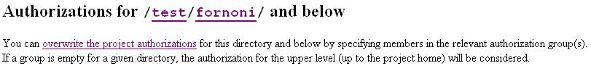

Access level restrictions
To sum up, ROCADE provides four levels of access level restrictions:
Username and password (provided by Helpdesk)
Project Level Permissions (set by project controller)
Encryption on files and/or https (set by project controller)
Folder level access (set by project controller)

Enabling HTTPS
This function is only available to Project Controllers. ROCADE provides encryption of communications for a specific project using https protocol. To access the project configuration, follow the steps explained in point 14 enabling file encryption. Two configurations are available for the option “HTTPSOnly” (Specifies if this project shall be accessed exclusively through HTTPS: Secure HTTP protocol).
0 = No, this project can be accessed through standard HTTP or through HTTPS
1 = Yes, any plain HTTP access shall be automatically redirected to the HTTPS web server for secure communication.
The defaut setting is 0.

Managing the distribution list

Hereafter is described the easiest method to create a mailing list; other methods more elaborated are explained in the webmaster.html file (http://rocade.esrin.esa.int/webmaster.html)
Now go to the index of your project. Scroll down the left frame of your window till you see the link to “List of Distrib. lists.” Click on the link. Now on the right frame you should have the following:
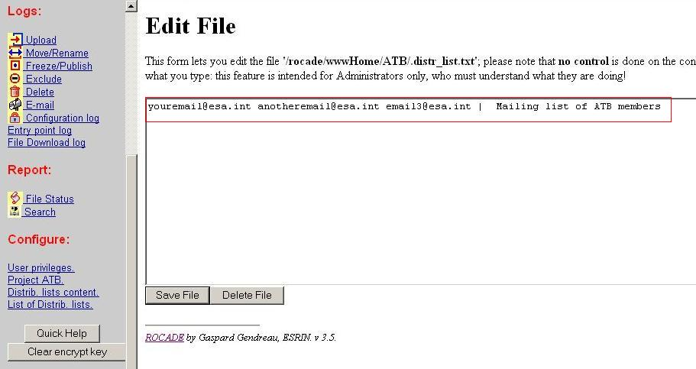
You can edit this file to add or remove or modify email addresses. Look carefully at the format of the distribution list: “distr_list_address | Short_Description_of_the_distr_list”. The format of each address is youremail@esa.int or hisemail@hotmail.com. You can add as many email addresses as you want by separating each of them with a space or a comma.
Then press the save button. The distribution list will be available to all users each time they upload a document.

Appendix 1: Options for each status
Documents in ROCADE are in one of four statuses: Check-in, Check-out, Frozen and Excluded. The flag  in the following tables indicates, for each status (column), if the action (row) is available.

Status  Actions | Checked-in | Checked-out | Frozen | Exclude | Published 
Check-in |  | 
Check-out | 
Freeze | 
Exclude |  |  | 
Delete |  |  |  |  | 
Cancel Check-out |  | 
Cancel Freeze |  |  | 
Cancel Exclude |  |  |  | 
E-mail |  |  |  |  | 
Move |  |  |  |  | 
Transfer |  |  |  |  | 
Rename |  |  |  |  | 
Update summary |  |  |  |  | 
Publish |  |  | 

For example, whatever is the status of the file; it is always possible to delete the file.

Note: Apparently, excluding a file which is marked “frozen” seems in contradiction with its final status. However, you may want this, for example if the scope of your project changes, or if a new document supersedes this document. This is why a frozen file can be excluded. ROCADE will however warn the user of this apparent contradiction.

Appendix 2: Rocade icons
ROCADE uses several icons to show the status of a given file, or provide access to various actions. Here is a summary table with the purpose of each icon.

Icon | Name | Contents & Purpose
 | Check-in | - File is Checked-in, i.e. it has been uploaded, and other users are authorised to check it out for further modification  - Click for info and actions on this file
 | Check-out | - File is checked out, i.e. someone is modifying it.  - Click for info and actions on this file (like upload a new version)
 | Frozen | - File is frozen, i.e. final version has been approved  - Click for info and actions on this file
 | Excluded | - File is obsolete; it is not deleted because it is part of the Project’s History.  - Click for info and actions on this file
 | Published | - The frozen file has been copied to another project (Published).  - Click for info and actions on this file
 | Summary info. | - Info and action on this file (This icon is used in place of one of the three previous icons when the system does not know the status of a file)  - Info includes Document Author, Title and reference  - Actions include Change status, Move, Rename, Delete, E-mail,...
 | History | - Complete history of the document since first upload  - Access to any previous version that was uploaded on the server
 | Upload log | - Log of the upload of all files
 | Move | - Log of files renamed or moved  - In the History, indicates the file has been renamed or moved to another directory
 | Freeze log | - Log of the freeze files
 | Exclude log | - Log of the file exclusions
 | Delete | - Log of the file deletion  - In the History, indicates the file has been deleted
 | Cancel Check-out | - In the History, indicates the Check-out of the file has been canceled
 | Cancel Freeze | - In the History, indicates the Freeze of the file has been canceled
 | Cancel Exclude | - In the History, indicates the Exclude of the file has been canceled
 | Quick report | - List all files within the current directory and below, sorted by status
 | Search | - Search for documents in the current Project by author, title or keyword.
 | Project Home | - Go to the Top level of the project
 | E-mail dist. lists | - Information on the e-mail distribution lists available
 | Privilege change log | - Log of the User Access Privileges changes.

